
Welsh Trampoline, Tumbling and DMT Open Championships and Cardiff Open 2024
Welsh TRA/TUM/DMT ticket link: https://welshgymnastics.sport80.com/public/wizard/e/192

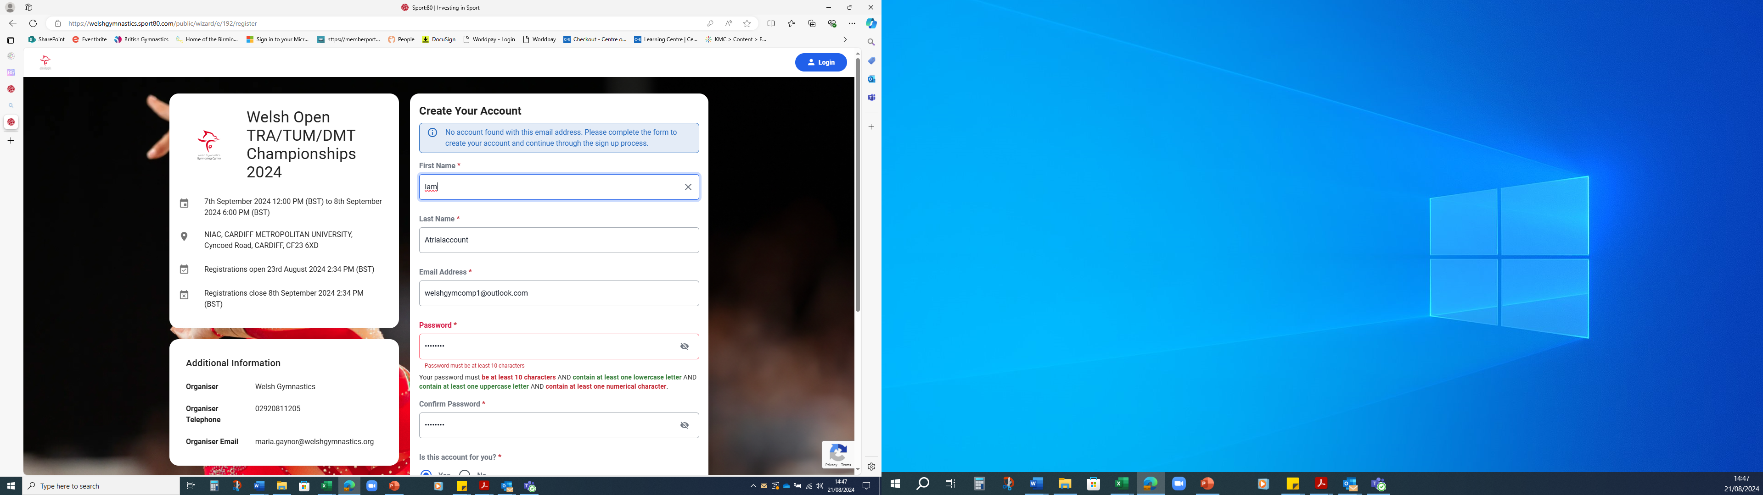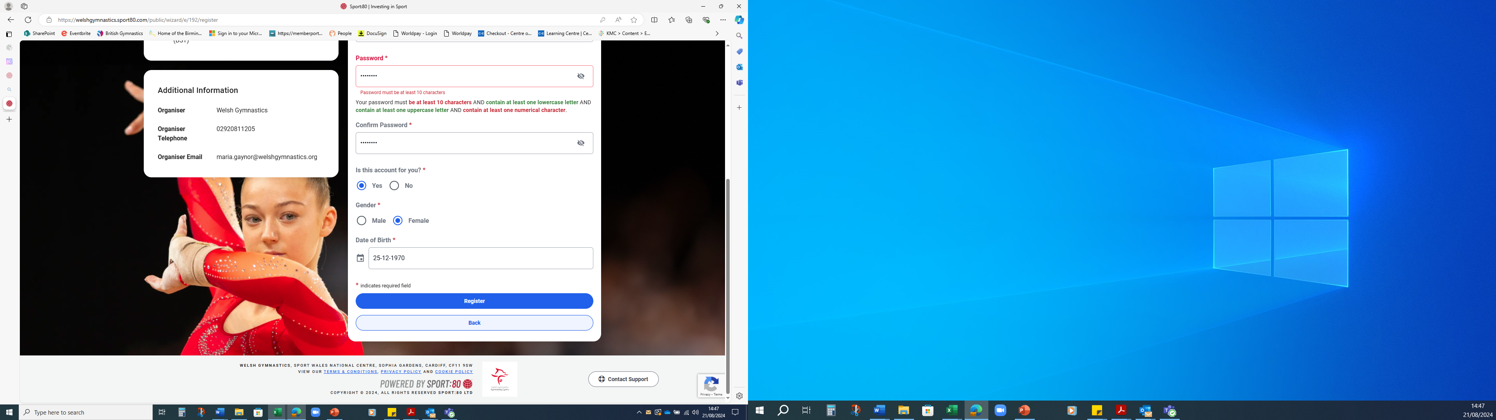
You will be asked to create a profile, if you already have a profile, proceed as you normally would.

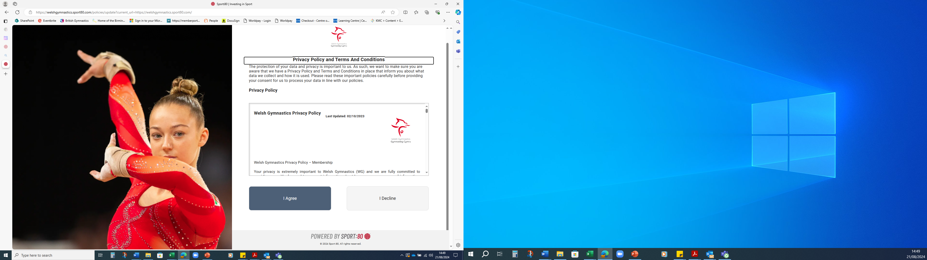
Please click I AGREE

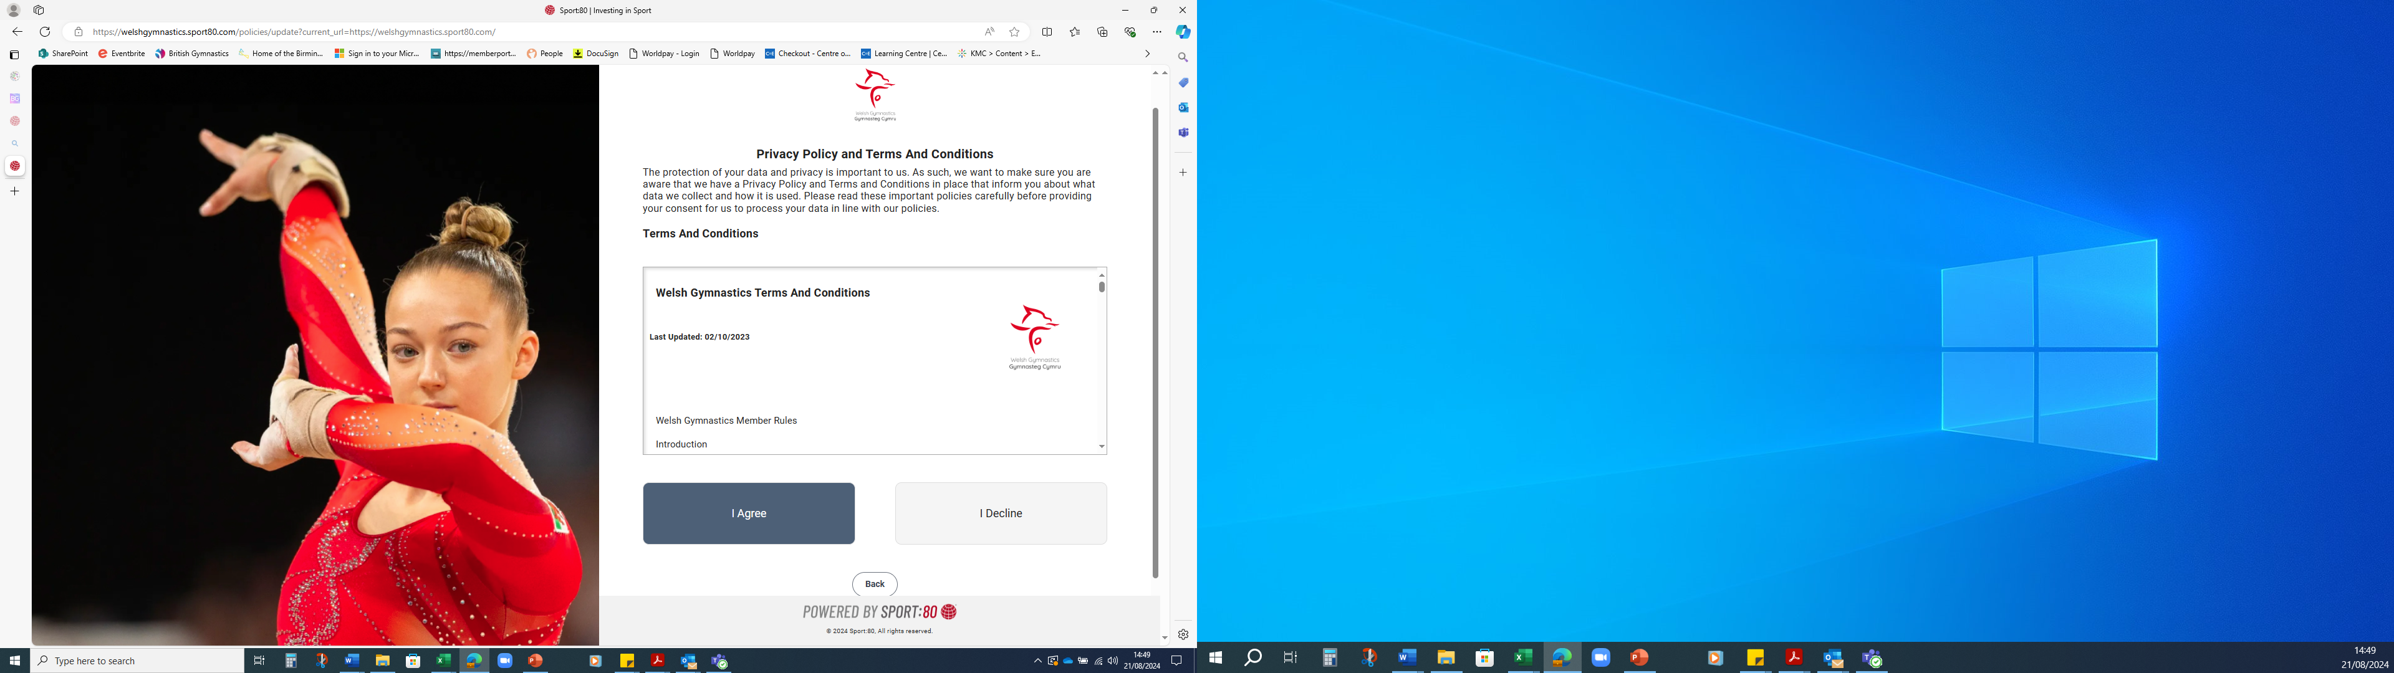
Please click I AGREE

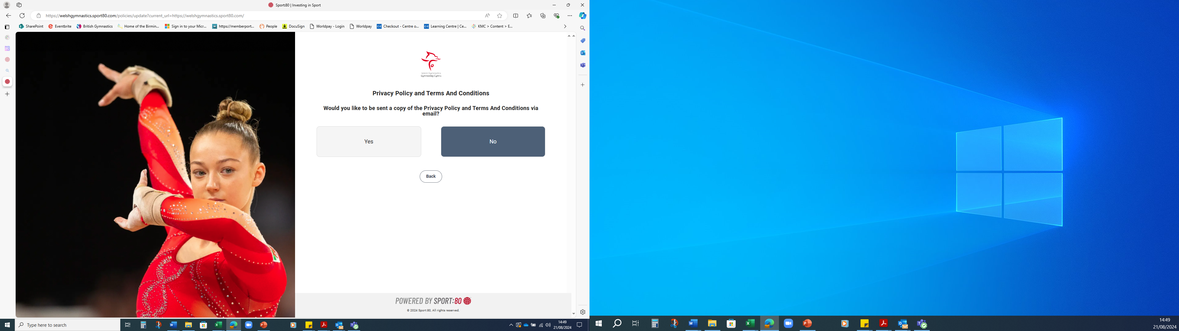
Please click your choice

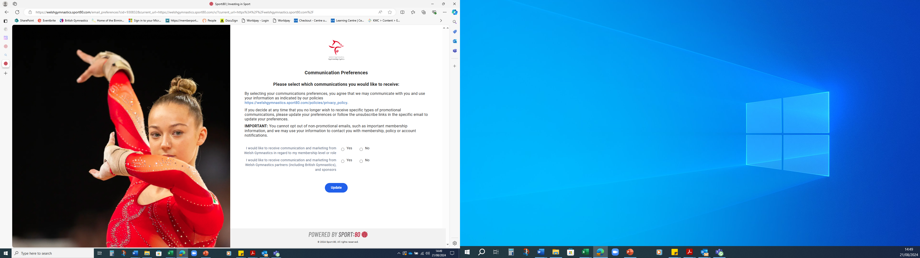
Please click your choice of preferences

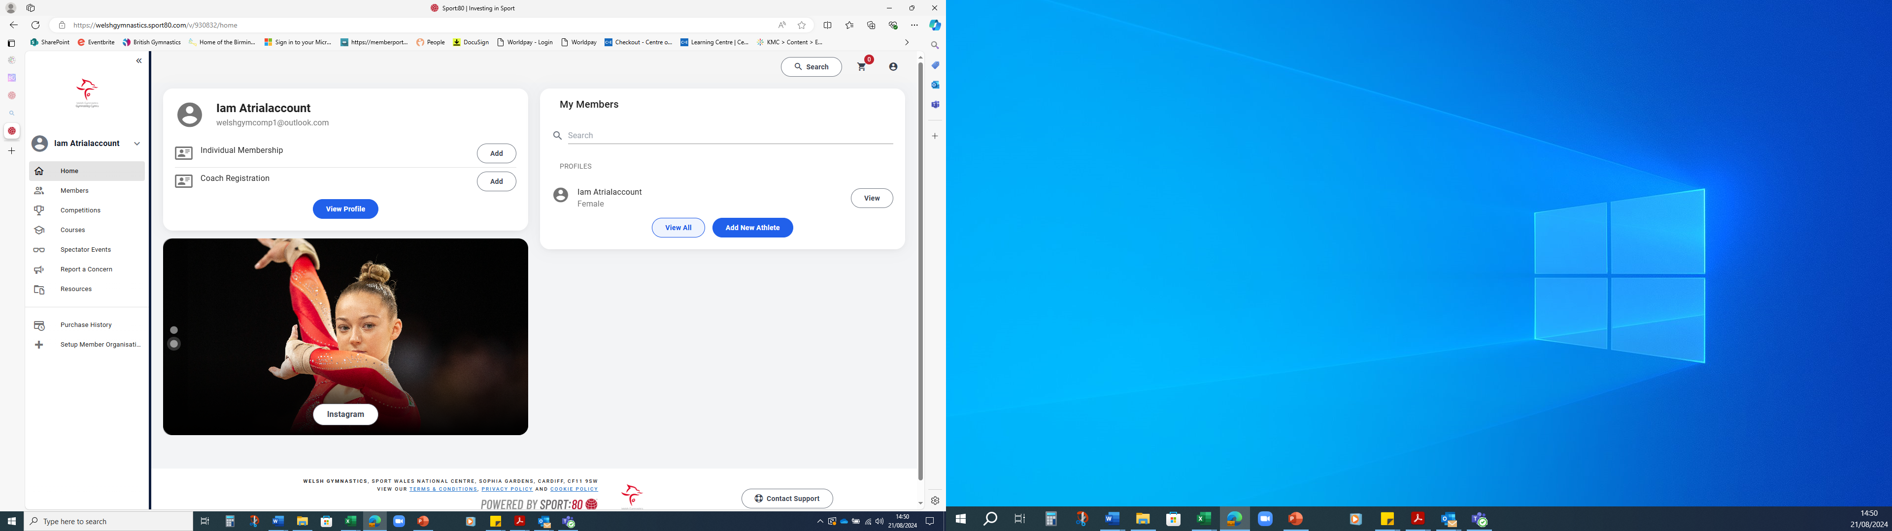
Please choose Spectator Events, chose the competition and your choice of tickets

