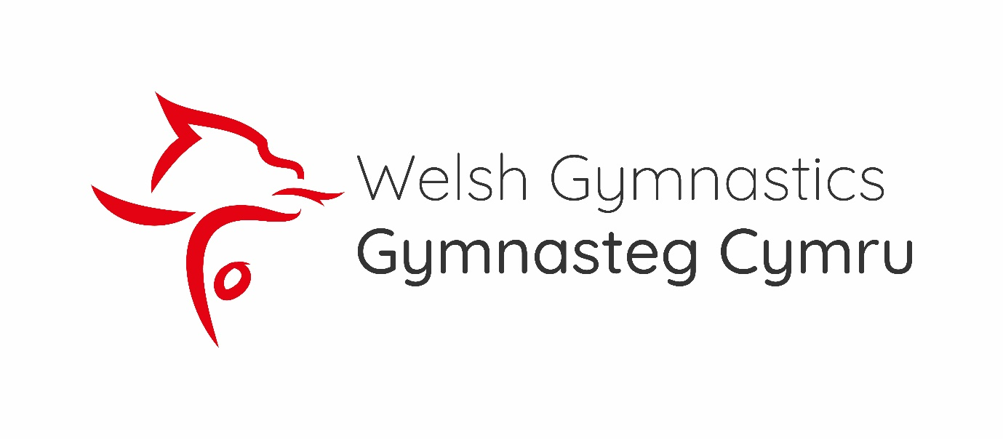

Welsh Rhythmic Open Championships
Future Hopes
2024
Scan here
LINK: https://www.eventbrite.co.uk/e/welsh-rhythmic-open-championships-and-future-hopes-2024-tickets-932303082617

ADULTS: £15
CHILD (over 14yrs): £8:50
Child under 4: FREE

