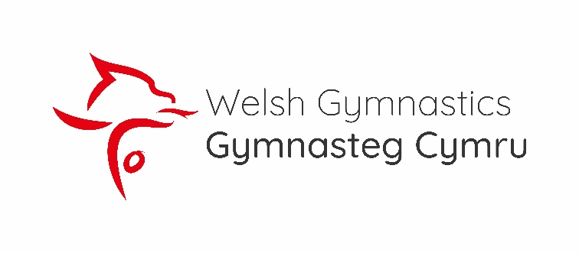
Hello, my name is Maria, I am your Floor Manager and also the Safeguarding/Welfare officer on Saturday. If you would like to talk please approach me – I promise I don’t bite!

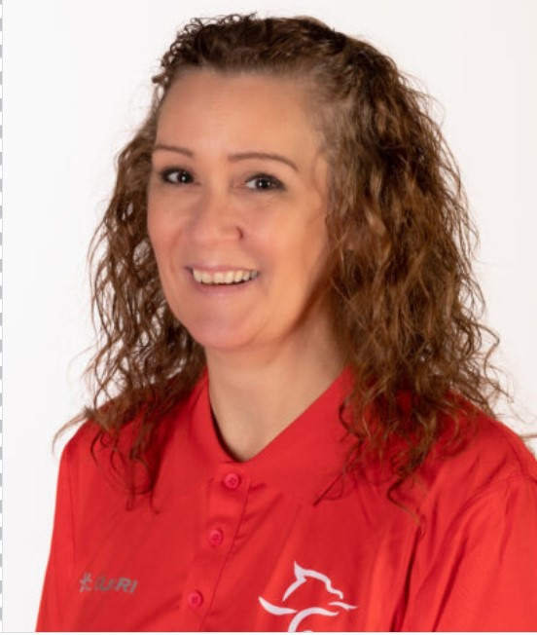
If there is an issue you would like to report please email: safeguarding@welshgymnastics.org
Hello, my name is Eirian and I am your Floor Manager and also the Safeguarding/Welfare Office on Sunday. If you would like to talk please approach me.
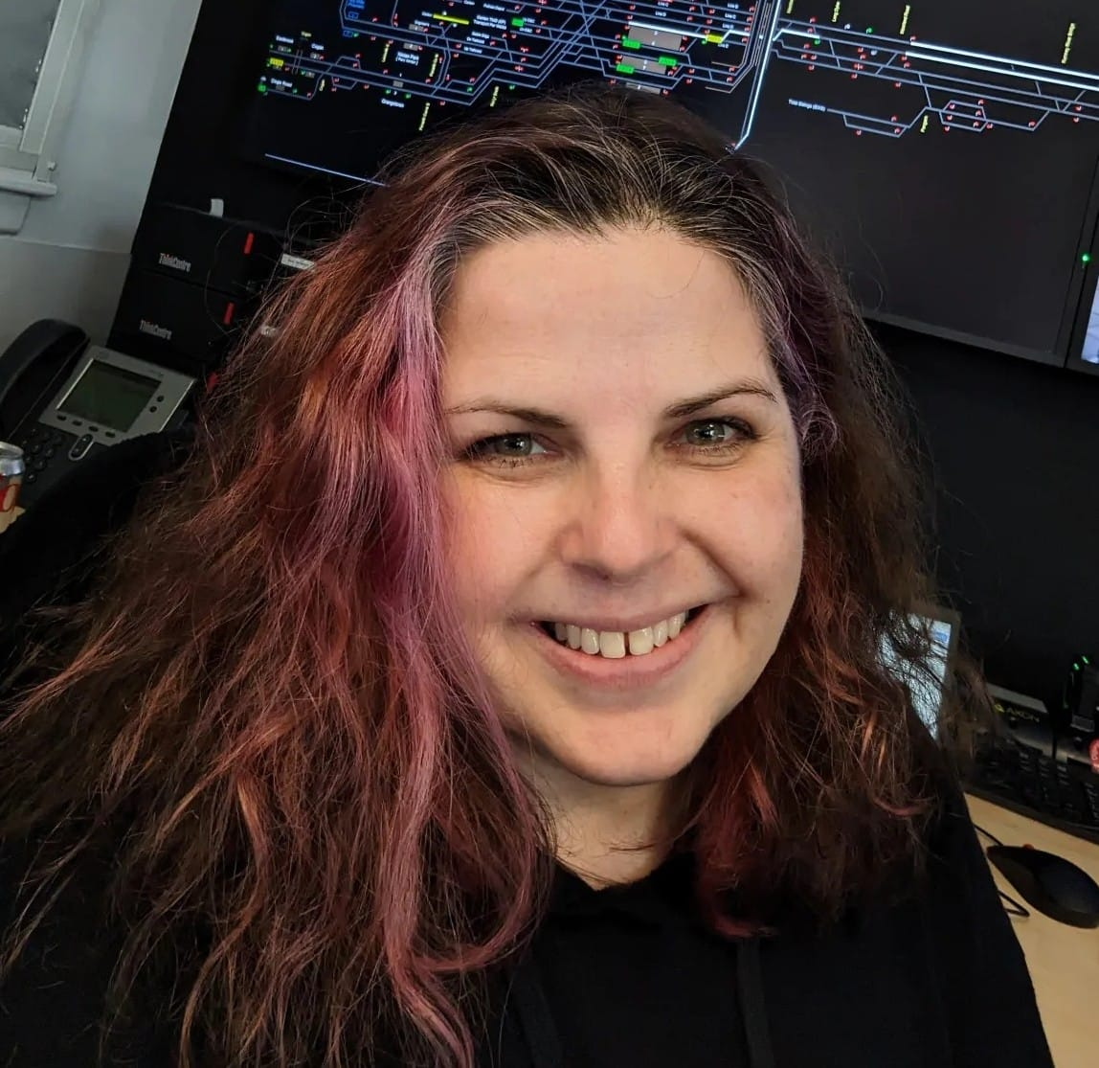
If there is an issue you would like to report please email: safeguarding@welshgymnastics.org

